FAST - Development Guidelines

FAST

Version: 1.1
- Revision History
Date | Version | Section | Revisions | Author | Reviewed and Approved By
10/23/2013 | 1.0 | All | Initial Draft | Ravindra Gupta
10/17/2013 | 1.1 |  | Added a new section 2.10. next gen – MVC - Controller | Prabhat Raja Peri
10/31/2013 | 1.2 | 2.1 | Added a new point under section 2.1. (II) | Abhijit Guha
11/14/2013 | 2.1 | 1.6, 1.7, 2.7,2.8, 3, 4 | Added UI section | Vanitha Nagaraj

Table of Contents
1. Production Code Development Guidelines 4
1.1. Naming Conventions 4
1.2. General Guidelines 6
1.3. Code Segregation 9
1.4. Business Objects 9
1.5. Service Layer 10
1.6. UI – Asp.Net 10
1.7. UI – JavaScript 11
1.8. UI – MVC 14
1.9. Service Interface 14
1.10. Database 14
2. Unit Testing Code Development Guidelines 14
2.1. Naming Conventions 14
2.2. Folder Structure 16
2.3. Testing Private Methods 16
2.4. Mocking 16
2.5. Business Objects 16
2.6. Service Layer 17
2.7. UI – Asp.Net 17
2.8. UI – JavaScript 17
Samples for JavaScript Modularization and Unit Testing 21
2.9. UI – MVC 24
2.10. Next Gen – MVC – Controller 24
Unit Testing Next Gen MVC Controller : 25
2.11.Service Interface 28
2.12.Database 29
3. Appendix – A 29
3.1 Sample I 29
3.2 Sample II 32
3.3 Sample III 37
3.4 Sample IV 46
4 Appendix – B 49

Production Code Development Guidelines

Naming Conventions
- Namespace names should follow the standard pattern.

<company name>.<product name>.<top level module>.<bottom level module>
FAF.BT.BS.EscrowClosingService

- .Net assembly should be extended with .Net.dll., ex. BusUint.Net.dll
- Use Pascal casing for Class names

public class DepositHistoryLoad
{
...
}

- Use Pascal casing for Method names

void Receipt(int fileID)
{
...
}

- Use Camel casing for variables and method parameters

void Receipt (int fileID)
{
int counter = 1;
...
}

- Use the prefix “I” with Camel Casing for interfaces ( Example: IEntity )
- Use Meaningful, descriptive words to name variables. Do not use abbreviations.

Use:
string address
int salary

Don't Use:
string nam
string addr

- Do not use single character variable names like i, n, s etc. Use names like index, temp

One exception in this case would be variables used for iterations in loops:
for ( int i = 0; i < count; i++ )
{
...
}
If the variable is used only as a counter for iteration and is not used anywhere else in the loop, many people still like to use a single char variable (i) instead of inventing a different suitable name.
- Do not use underscores (_) for local variable names.
- All member variables must be prefixed with underscore (_) so that they can be identified from other local variables.

private int _recordId ; //Do not use Hungarian notation.
- Do not use variable names that resemble keywords.
- Prefix boolean variables, properties and methods with “is” or similar prefixes.

Example : private bool isFinished

- Use appropriate prefix for the UI elements so that you can identify them from the rest of the variables. A brief list is given below. Since .NET has given several controls, you may have to arrive at a complete list of standard prefixes for each of the controls (including third party controls) you are using.

Control | Prefix
Label | lbl
TextBox | txt
DataGrid | dtg
Button | btn
ImageButton | imb
Hyperlink | hlk
DropDownList | ddl
ListBox | lst
DataList | dtl
Repeater | rep
Checkbox | chk
CheckBoxList | cbl
RadioButton | rdo
RadioButtonList | rbl
Image | img
Panel | pnl
PlaceHolder | phd
Table | tbl
Validators | val

General Guidelines
- Avoid instantiating concrete classes inside methods with logic. Get instances of classes from helper methods, factories, Inversion of Control containers such as Unity, or other places, but don’t directly create them. This allows you to serve up your own fake instances of classes to methods that require them, instead of being tied down to working with an internal production instance of a class.
- Avoid DB calls from methods with logic, place such code in helper method and call it from your main method. This will help in unit testing your main method with business logic by overriding definition of helper method to isolate DB call.
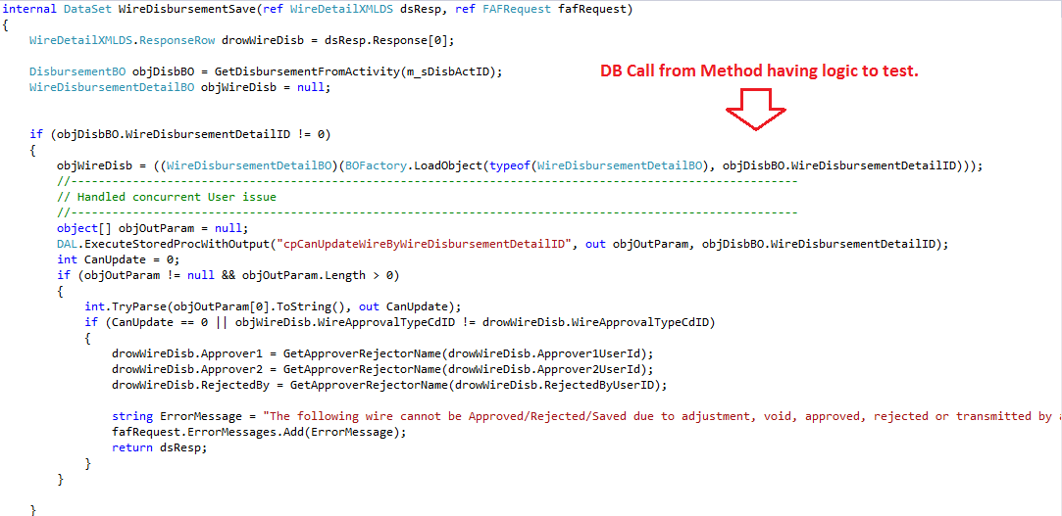
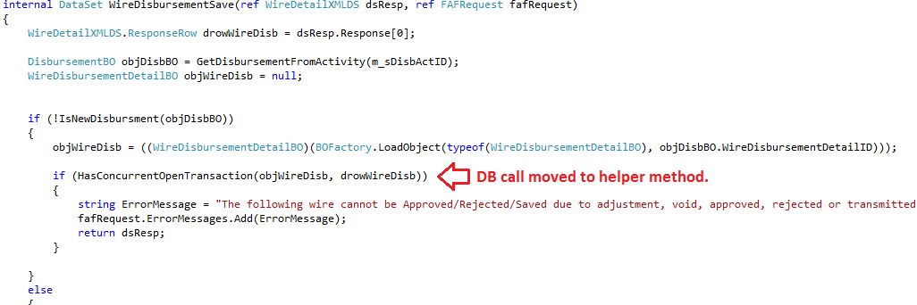
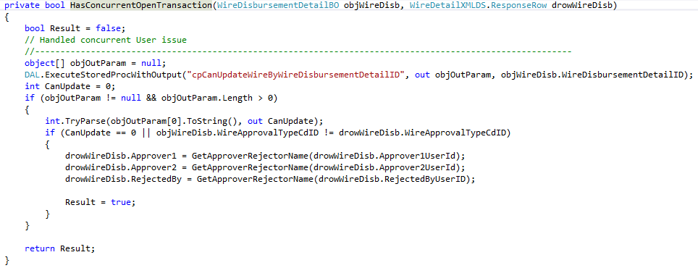
- Avoid constructors and static constructors that do logic or create instances of collaborators. Overriding constructors is difficult to implement. Keeping constructors simple will simplify the job of inheriting from a class in your tests. Also use interface-based designs and dependency injection for collaborators. This allows you to use polymorphism to replace dependencies in the system with your own stubs for unit testing.
Instead of creating instances of collaborator in constructor use interface based design and pass Interface to use in constructor.
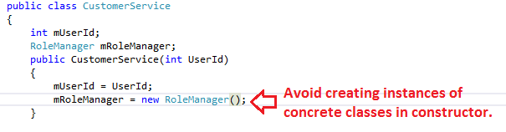
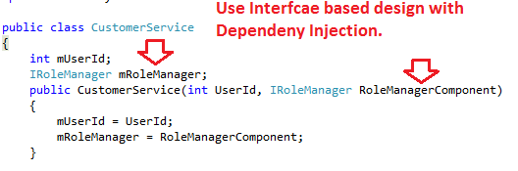
- Write smaller, more targeted methods. Doing so you should be able to write more focused and easier to write tests. A method size should not exceed 50 lines; refactor your code once you are done with construction in cases where number of lines is greater than 50. Follow single responsibility principle.
- Do not use hardcoded numbers for domain values in business logic, consider using Constants/Enums. If to be accessed by multiple classes/ components, these Constants/Enums should be defined in common classes/modules.
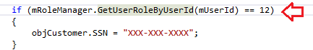
Instead of using hardcoded constant in actual logic use Enums/common constants:
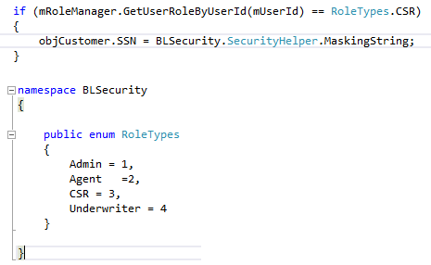
- Methods and classes should be documented using standard .NET comments.
- Code handles errors properly (preconditions, exceptions, etc.).
- Make sure errors messages and logs are meaningful.
- No commented out code. Remove it. All historical code can be retrieved from TFS
- Generic collections are preferred because they provide type safety. Instead of Array List, use List<T>. For storing strings, use String Dictionary instead of Hash table.
- Switch statements are preferred over a lengthy series of if statements. When using switch, always have a default.
- Using statements in a file should list the namespaces in alphabetical order.
- Make sure code does not contain unused namespace references.
- Optimize if statements in C# code where possible to limit the number of conditions being checked.
- Use try/finally on disposable resources and close resources you open.
- Use String Builder for string manipulation.
- Utilize the C# using statement with IDisposable objects to ensure the objects are disposed of properly.
- If you are doing case-insensitive comparisons, use String. Compare instead of converting strings to uppercase/lowercase and comparing.
- Data variables should be tightly casted. Don’t use var if you know the data type
- Eating Exceptions-Never use an empty catch{}
- Use Using(){} to write more concise code.
- If a method returns reference type then don't instantiate the object type and then reassign the object the reference object, instead directly call the method and get assign the reference object.
- Exercise caution when re-throwing exceptions-Never re-throw exceptions.
- Do not initialize default values for local values. The common language runtime initializes all fields to their default values automatically before running the constructor.
- If a statement or operation does not depend on the loop iteration, do not have it inside the loop.

Code Segregation
Business logic should not be added to UI layers.

Business Objects

Service Layer
- Do not directly refer concrete Business objects, service handlers should always be dependent on BO Interfaces.
- Do not access Session variables directly in Service Handlers, this information should be passed to service handlers as part of request object. Service handlers should not be dependent on HTTP Context in any way.

UI – Asp.Net
- All guidelines in section 1.2 are duly applicable to code behind.
- Decouple the calculation/ business logic from codebehind (i.e.) HttpContext objects, page and control events , move them to respective service layers wherever possible.
- Write equivalent function for dynamic JavaScript on code behind in respective .js wherever possible. Keep the function calling logic at server side with appropriate parameters. For example, the below code snippet can be a function taking url as parameter and removed from code behind.
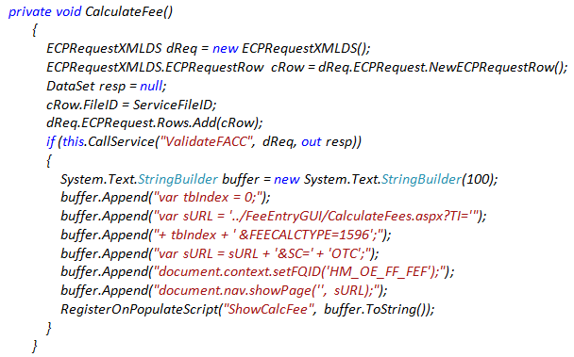
Below code from ECProcessGUI\OECDetail.aspx, is calling method with proper input parameter from GUIUtils\FAFPage.js, a sample for good code.
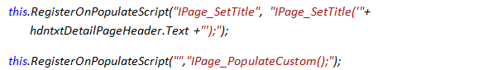
- Most of the logics in code behind deals with entire schema when only a subset of details is required. Refactor the code to handle minimal schema data for any calculation or validation.
- Decouple reusable code like formatting , control validations that have generic logic as shown below and move to FAF20\UI\UIHelper\ UIHelper.csproj .
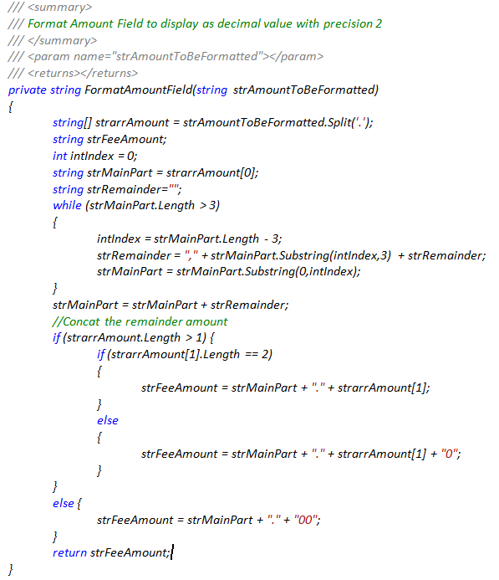
- Organize the UIHelper project as below
  - Solution Path : FAF20\UI\UI.sln
  - Namespace : FAF.FAST.UIHelper
  - Project Names : UIHelper.csproj

- Move the validation logics against schema or PageData objects to respective Service Layer.
With this, target for no Code behind unit testing for business validations except UIHelper.

UI – JavaScript
- In general, keep DOM manipulation script separate from script for business logic. Segregate them under respective JavaScript file(s) for better testability.
- Move all the JavaScript code from html/aspx to respective JavaScript files.
- Move framework and business logic code at the global level to modularized functions.
- Refactor code to have proper input parameters and appropriate return values. Below example from EscrowClosingGUI\HUD1Print.js checks if the borrower or seller text having ‘et al’ in their names.
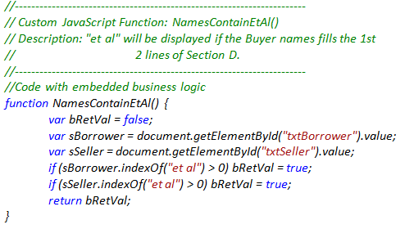
This code can be converted into reusable function taking two inputs (i.e.)source string and search string returning true or false as shown below.
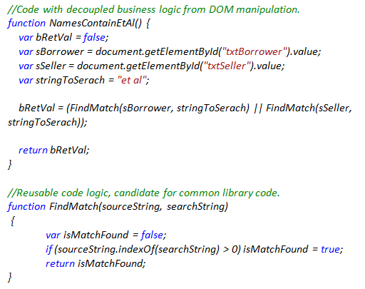
- Write smaller, more targeted methods. Doing so you should be able to write more focused and easier to write tests. A method size should not exceed 25 lines; refactor your code once you are done with construction in cases where number of lines is greater than 25. Follow single responsibility principle.
- Do not use hardcoded numbers for domain values in business logic. Consider using FAF20\UI\UIHelper\JSHelper\Enum.js. For Example, Enums like TypeCdID and other hardcoded numbers to be brought down to JavaScript JSHelper library.
- Avoid Using Eval wherever possible particularly when the input comes from user. The Eval function allows us to pass a string to the JavaScript compiler and have it execute as JavaScript which is potential security threat and also have impact on performance because of non-availability of code for optimization during design. Here is the code from AddressbookGUI\BusContactSetUp.aspx.
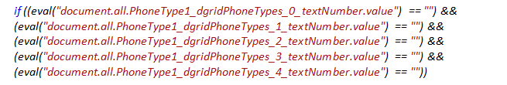
The following code snippet shows how eval can be gracefully removed.
- Move code for generic validation, formatting, conversions, etc. to UIHelper library. For example the following code to be moved from OpenOrderGUI/NewFileEntry.js to FAF20/UI/UIHelper/JSHelper/Helper.js.
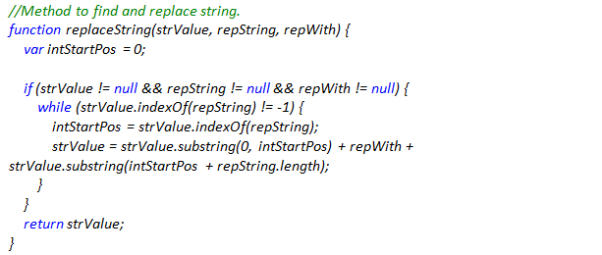
Other functions to be moved to common helper from NewFileEntry.js are
  - replaceString(strValue, repString, repWith)
  - IsNotEmpty(aTextField)
  - IsDDNotEmpty(aDropDownField)
  - hasInvalidCharacters(elem)

- Always explicitly declare a variable with var keyword at proper scope. Failure to do so attach your new variable to the global scope. 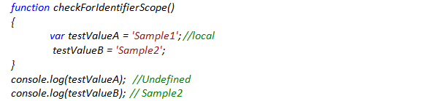
- Modularize code without repeating the validation in every unit. Check for validation at framework level, calling hierarchy, etc... For example, the sample III at Appendix – A, need not have validation for invalid inputs as validation is taken care in the invoking code and also in FAFControls.

- Don’t use the keywords for identifiers or functions. Below are some of the keywords used by Jasmine testing framework used for JavaScript testing.
  - describe
  - it
  - beforeeach, aftereach
  - actual
  - NotEqual
  - toBe, etc..

- Move the common code for formatting, validation, manipulation into common helper files segregated for individual controls. For example, the code below to be moved to FAF20/UI/UIHelper/JSHelper/TextHelper.js.

UI – MVC

Service Interface

Database

Unit Testing Code Development Guidelines

Naming Conventions
- For every module/component to test we will have one Unit Test project. Name this project as per pattern below:
FAF.FAST.<<Component Under Test>>.Test
- Name all the Test Classes as per pattern below:
<<ActualClassName>> UnitTest
- Common Logics which could be used across projects should be placed in
FAF.FAST.UnitTesting.Common
- Name of unit test should be descriptive enough to describe the scenario covered in test.
Example: If_Commission_Is_Flat_Value_Do_Not_Apply_Percentage.

- Every test method should be decorated with attribute:
[TestProperty("MethodUnderTest", "<ClassName_Name of Method this test case is testing>")]
Example: [TestProperty("MethodUnderTest", "CommissionCalculater")]
This will help us in grouping/filtering test cases based for any method.
- Every Test Classes should be derived from “FAF.FAST.UnitTesting.Common.UnitTestBase” wchich is part of
Do not use assertion method provided by BCL class Assert , use assertion methods which are part of class FAF.FAST.UnitTesting.Common
Incorrect code: Assert.AreEqual(Expected,actual);
Correct code: AreEqual(Expected, actual,”ErrorMessage”);
- Error message added to assert should be descriptive, one should be able to understand reason of failure by reviewing test run results.
- Follow AAA (Arrange, Act, and Assert) pattern. By following this industry convention, the code is simply presented, structured more cleanly and is also easier to read. In large test libraries this makes things much more maintainable.
- Document your test code – As unit tests validate the feature and business requirements, the code itself is a living documentation of the system.
- The unit test should be as simple, clean, and concise as possible. It should be perceived as a valuable asset for testing and documentation; otherwise, it might become an ignored maintenance mess.
- Each test should only have one logical assertion. It should validate the unit test, as indicated by its descriptive name. A logical assert can contain one or more assert statements.
- Test the good, the bad and the edge case. The unit test should cover all possible scenarios and strive for high code coverage. Testing edge cases and exceptions are the responsibility of the tester, not the end user.
- Follow same naming conventions as defined for production code for unit testing code (in addition to naming conventions for unit test name).

- Refactor unit testing code to have common logic segregated in helper methods.

Folder Structure
Unit test cases are segregated into four solution folders:
- UintTestCommon : This will have unit testing specific common projects.
- UnitTestBO: This will have one unit project for each Business Object project.
- UnitTestBS: This will have one unit project for each Service Handler project.
- UnitTestUI: There will be only one unit test project for UI layer, for each corresponding UI project under test, a folder will be added to UnitTestUI project – Name of this folder will be same as UI project/folder name.
Please assure that unit test cases created for any BO, Service Handler or UI project is added to corresponding project as specified in above list.

Testing Private Methods

Mocking

Business Objects

Service Layer

UI – Asp.Net
Organize the test hierarchy as below
  - Solution Path : FAF20\UnitTestUI\UnitTestUI.sln
  - Namespace : FAF.FAST.UI.Test
  - Project Name : FAF.FAST.UI.Test.csproj
  - UIHelperTest : FAF20\UnitTestUI\FAF.FAST.UI.Test\UIHelper\Test files for Helper classes

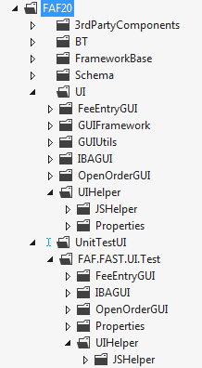
No Code behind unit testing except UIHelper.

UI – JavaScript
- Unit test code for all java scripts is organized under a FAF.FAST.UI.Test.csproj project with respective folder names matching the UI project name. Place the JavaScript test files under corresponding folder.

  - Project Name : FAF.FAST.UI.Test.csproj
  - JSHelperTest : FAF20\UnitTestUI\FAF.FAST.UI.Test\UIHelper\JSHelper\HelperUnitTest.js
  - OpenOrderGUI : FAF20\UnitTestUI\FAF.FAST.UI.Test\OpenOrderGUI\ NewFileEntryUnitTest.js

- Download and install Chutzpah, an open source JavaScript test runner which enables JavaScript unit tests execution from Visual Studio with test explorer integration.
- Source : 3rdPartyComponets/ Chutzpah [http://visualstudiogallery.msdn.microsoft.com/f8741f04-bae4-4900-81c7-7c9bfb9ed1fe]

- TFS Adapter/ plugin will be installed in TFS 2012 sandbox.
Source : [ http://blogs.msdn.com/b/visualstudioalm/archive/2012/07/09/javascript-unit-tests-on-team-foundation-service-with-chutzpah.aspx]

- Refer Jasmine Framework for JavaScript testing from
Source : 3rdPartyComponets/jasmine-1.3.1

Jasmine is an open source, automated testing framework for JavaScript, having adaptor to Test Explorer and TFS 2012. Jasmine has better assertions compared to Qunit, custom matchers and support for asynchronous specifications.

- A test suite begins with a call to the global Jasmine function describe with two parameters: a string and a function.
- Specs are defined by calling the global Jasmine function it, which takes a string and a function. The string is a title for this spec and the function is the spec, or test.
- Name of unit test (i.e.) Suits and Specs in Jasmine should be descriptive enough to describe the scenario covered in test. Refer following example
  - Test Suite : Test Definition - CalculateFees – SplitByPercentage
  - Test Spec : By Buyer Split - Valid Input
- An expectation [matcher] in Jasmine is an assertion that can be either true or false.
- Variables declared in a describe suite are available to any it block inside the suite.
- Suites and specs can be disabled with the xdescribe and xit functions, respectively.
- Jasmine built-in matchers are following
  - expect(x).toEqual(y); compares objects or primitives x and y and passes if they are equivalent
  - expect(x).toBe(y); compares objects or primitives x and y and passes if they are the same object
  - expect(x).toMatch(pattern); compares x to string or regular expression pattern and passes if they match
  - expect(x).toBeDefined(); passes if x is not undefined
  - expect(x).toBeUndefined(); passes if x is undefined
  - expect(x).toBeNull(); passes if x is null
  - expect(x).toBeTruthy(); passes if x evaluates to true
  - expect(x).toBeFalsy(); passes if x evaluates to false
  - expect(x).toContain(y); passes if array or string x contains y
  - expect(x).toBeLessThan(y); passes if x is less than y
  - expect(x).toBeGreaterThan(y); passes if x is greater than y
  - expect(function(){fn();}).toThrow(e); passes if function fn throws exception e when executed.
Negative matches are
  - not.toEqual
  - not.toBe
  - not.toMatch and
  - not.toContain,
  - toFalsy
  - toTruthy
  - toContain, etc... respectively.

- Jasmine gives the flexibility of creating custom matcher required for assertions. They should be added inside beforeeach function. Below is a sample for custom matcher

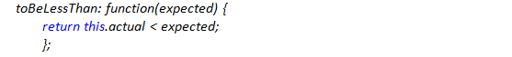

- Add the following reference to jasmine test file (i.e.) <test>.js file along with source test file and respective references.

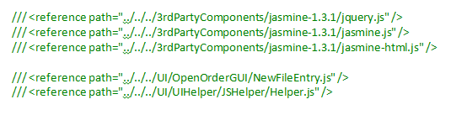

- Create spec.html file which Jasmine calls to provide results of each spec and suite, also used for debugging test code. The reporter is responsible for presenting results to the user Do not check in html file into TFS. Refer Appendix – B.
- Jasmine extends comprehensive mocking framework for testing the code in isolation by removing the interactions with external system or functions with Spy or DOM objects with dummy.
- SpyOn function is used to mock method of an object .The method to be mocked should be defined inside an object, and methods in js outside object scope can’t be mocked.
  - Syntax : spyOn(object, “methodName”)

Refactored Code
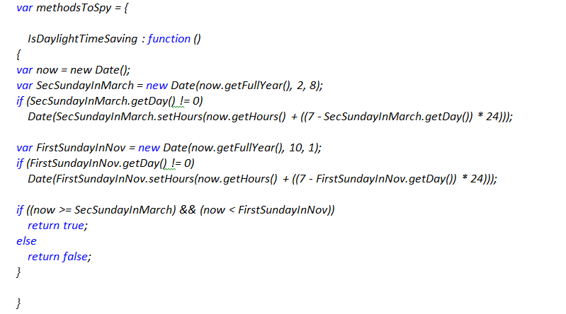

Test Code
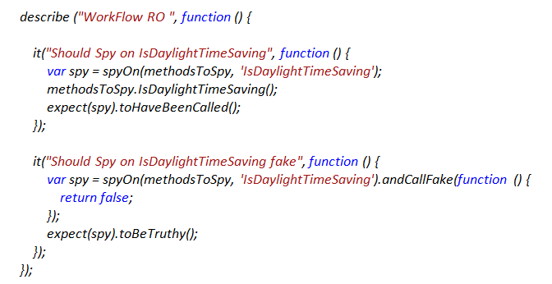

- Jasmine spy can be called with following attributes
  - andCallThrough : tells spy to call through the actual implementation.
  - andReturn : for setting the return value of a spy.
  - andCallFake : calls an alternate implementation when spy is called.
  - andThrow : for throwing an exception when the spy is called.

- Jasmine spy matchers are below
  - toHaveBeenCalled : return true if the spy was called.
  - toHaveBeenCalledWith : return true if the argument list matches any of the recorded calls to the spy.
  - Etc..
- Jasmine also has support for running specs that require testing asynchronous operations.

Samples for JavaScript Modularization and Unit Testing
Sample I

The following code from NewFileEntry.js, having the business logic intermixed with DOM manipulation and same code is repeated to handle multiple drop downs. This example shows refactoring reusable code form UI manipulation and testing with DOM injection using Jasmine fixtures. Refer complete code attached in Appendix – A – Sample I.

Existing Code

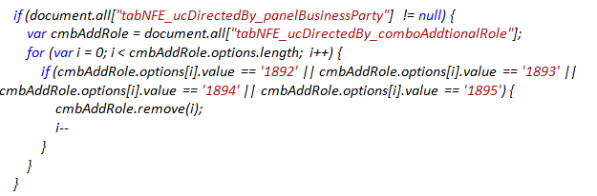
Refactored Code
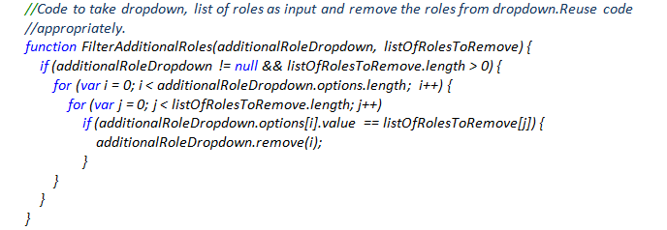
Test Code – Jasmine
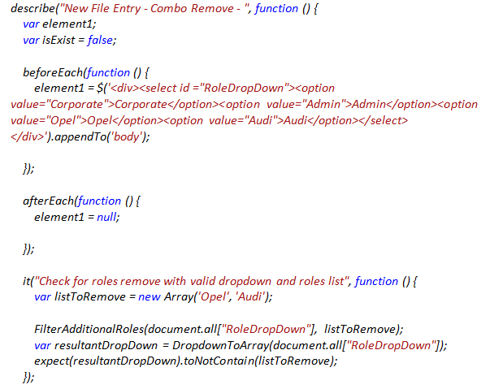

Sample II

This example shows refactoring reusable code form extensive DOM manipulation and testing without DOM injection. Refer complete code attached in Appendix – A – Sample II.

In role maintenance screen, the logic for activity right setting having mutually exclusively business rules which requires validation at the client end.

Role Maintenance Screen:

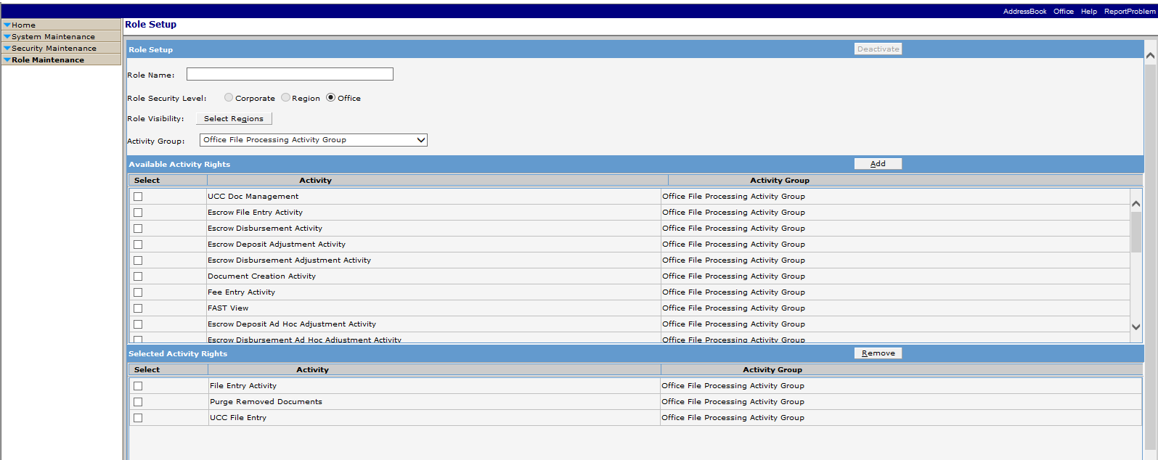
Existing Code
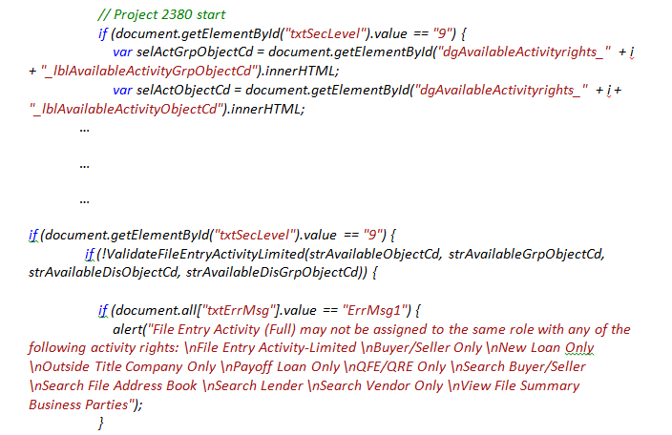
Refactored Code
This takes activity Rights as array input and validates the same rules and returns appropriate error message for alert display.

Sample III

This example shows refactoring reusable calculation logic and modularizing code form UI manipulation and testing without DOM injection. Refer complete code attached in Appendix – A – Sample III.
- Highlighted code is the calculation logic repeated multiple time at various functions mentioned below, which can moved out as reusable function.
  - SplitFee(id,Category)

  - UpdateSplitPercntgAndAmount(iChargeTo, SplitPrcntg, SplitAmnt, TotalAmnt, txtSeller, txtBuyer,splitAmntCntrl,txtTotal)

  - setPreValue(rowid, buyerCharge, sellerCharge, splitPercntg, splitAmnt, assignedTo)
Existing Code
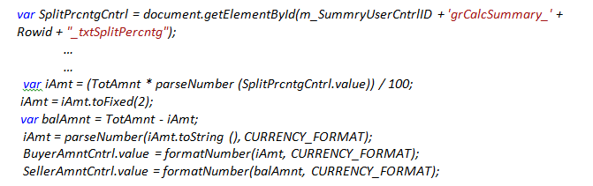
Refactored Code
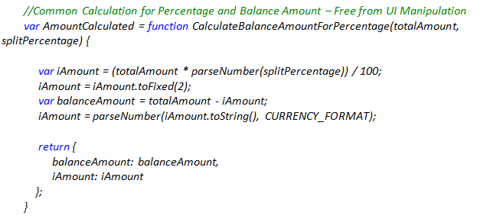
Test Code
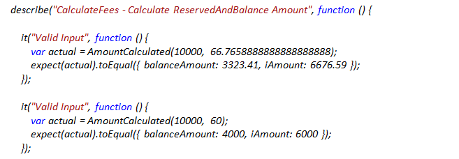
In the above Figure, the test care is having no negative case added, as the validation in the application logic takes care of it, (i.e.) Negative number by FAF controls, split Percentage is not greater than 100 by Splitfee function.
Sample IV

This sample shows how to organize common Code and test. Refer complete code attached in Appendix – A – Sample IV.

UI – MVC

Next Gen – MVC – Controller
Next Gen application is dependent on same service handers which are part of FAST service layer and for UI Asp.Net MVC is used. For purpose of unit testing in addition to service handlers which are covered in service handler testing, unit testing for controllers is required.

Unit Testing Next Gen MVC Controller :
- Testing Support in ASP.NET MVC : Model View Controller (MVC) pattern is inherently testable as it encourages separation of the application flow logic and the display logic.
- Next gen controller(DocPrepController) is dependent on the docprep service for all the operations done in it .
- Next gen controller uses dependency injection to isolate the dependency on docprep service by exposing an interface(IDocPrepService) which makes testing the controller actions easier.
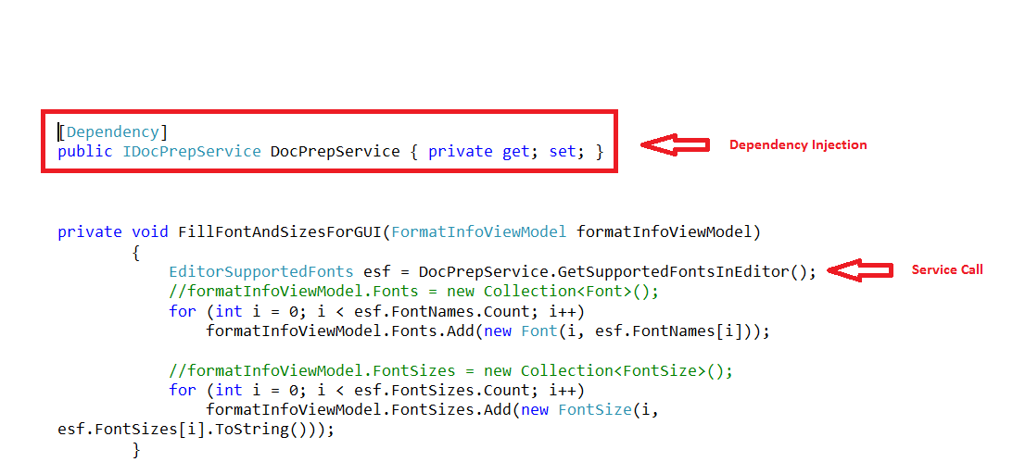

- Mock the IDocPrepService interface using Stubs to detour it’s method calls and provide the mock definition of the required method for unit testing.
- The method calls made through the IDocPrepService requires the ServiceContext property as one of its parameters. So mock the ServiceContext using Shims.

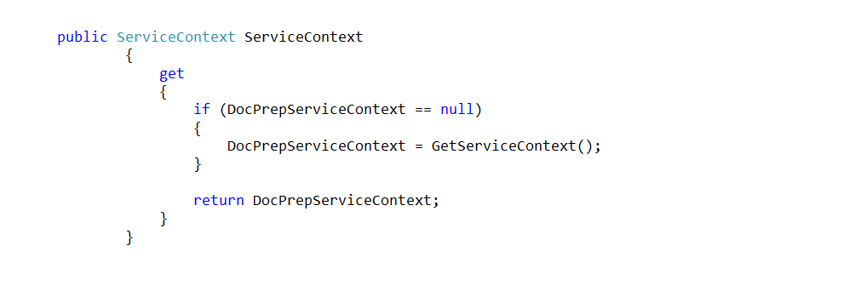

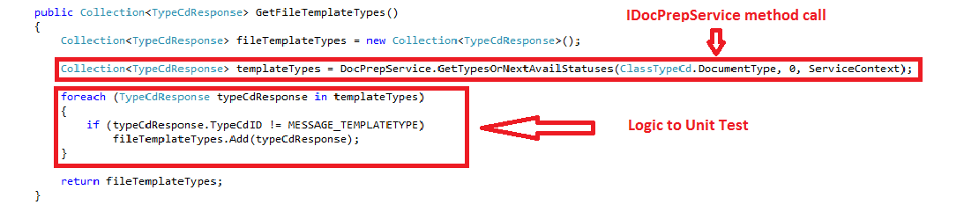

Unit Test case for the above method GetTemplateTypes():

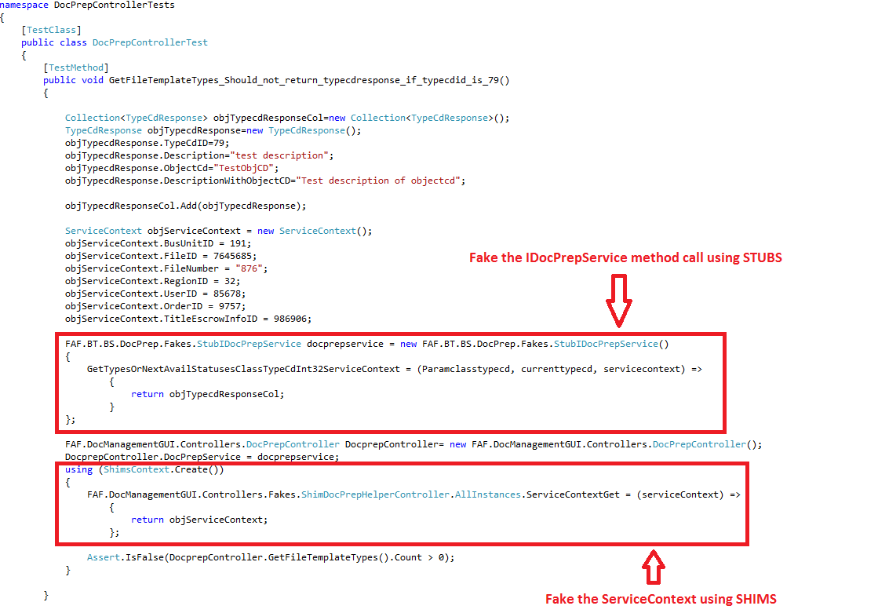

What can be tested in the DocPrepController :
- Methods can be tested to check if they are returning the expected view.
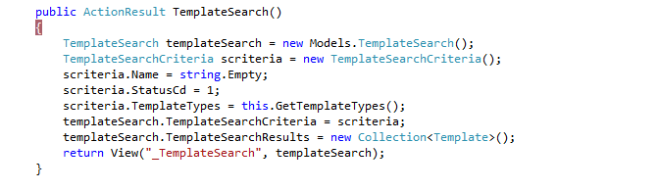
Unit Test case for the above method TemplateSearch():
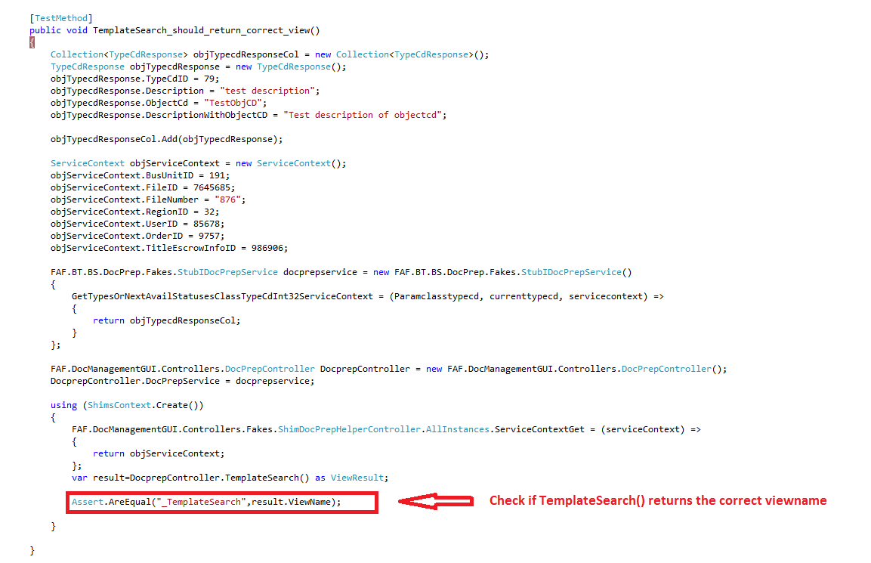
- Methods having some logic can be tested to check if it works fine. For such methods identify and isolate the testable logic to another helper methods which can then be unit tested separately.

2.11.Service Interface

2.12.Database

Appendix – A
This section contains the code samples for JavaScript unit testing with all edge cases.

Sample I
Existing Code : [ NewFileEntry.js]

//Fix for Ticket 3776874
function FilterAddlRoles() {
if (document.all["tabNFE_ucBusinessSource_panelBusinessParty"] != null) {
var cmbAddRole = document.all["tabNFE_ucBusinessSource_comboAddtionalRole"];
for (var i = 0; i < cmbAddRole.options.length; i++) {
if (cmbAddRole.options[i].value == '1892' || cmbAddRole.options[i].value == '1893' || cmbAddRole.options[i].value == '1894' || cmbAddRole.options[i].value == '1895') {
cmbAddRole.remove(i);
i--
}
}
}

if (document.all["tabNFE_ucDirectedBy_panelBusinessParty"] != null) {
var cmbAddRole = document.all["tabNFE_ucDirectedBy_comboAddtionalRole"];
for (var i = 0; i < cmbAddRole.options.length; i++) {
if (cmbAddRole.options[i].value == '1892' || cmbAddRole.options[i].value == '1893' || cmbAddRole.options[i].value == '1894' || cmbAddRole.options[i].value == '1895') {
cmbAddRole.remove(i);
i--
}
}
}
if (document.all["tabNFE_ucAssoBusParty_panelBusinessParty"] != null) {
var cmbAddRole = document.all["tabNFE_ucAssoBusParty_comboAddtionalRole"];
for (var i = 0; i < cmbAddRole.options.length; i++) {
if (cmbAddRole.options[i].value == '1892' || cmbAddRole.options[i].value == '1893' || cmbAddRole.options[i].value == '1894' || cmbAddRole.options[i].value == '1895') {
cmbAddRole.remove(i);
i--
}
}
}

Refactored Code:
//Code used at page level to remove the roles from BusinessParty dropdown.
function FilterAddlRoles() {

var listOfRolesToRemove = [TypeCategory_Energy, TypeCategory_Corporate, TypeCategory_SpecialServicer, TypeCategory_Government];

if (document.all["tabNFE_ucBusinessSource_panelBusinessParty"] != null) {
FilterAdditionalRoles(document.all["tabNFE_ucBusinessSource_comboAddtionalRole"], listOfRolesToRemove);
FilterAdditionalRoles(document.all["tabNFE_ucDirectedBy_comboAddtionalRole"], listOfRolesToRemove);
FilterAdditionalRoles(document.all["tabNFE_ucAssoBusParty_comboAddtionalRole"], listOfRolesToRemove);
}
}

//Code to take dropdown, list of roles as input and remove the roles from dropdown.Reuse code //appropriately.
function FilterAdditionalRoles(additionalRoleDropdown, listOfRolesToRemove) {
if (additionalRoleDropdown != null && listOfRolesToRemove.length > 0) {
for (var i = 0; i < additionalRoleDropdown.options.length; i++) {
for (var j = 0; j < listOfRolesToRemove.length; j++)
if (additionalRoleDropdown.options[i].value == listOfRolesToRemove[j]) {
additionalRoleDropdown.remove(i);
}
}
}
}

Text Code:

/// <reference path="../../../3rdPartyComponents/jasmine-1.3.1/jquery.js" />
/// <reference path="../../../../3rdPartyComponents/jasmine-1.3.1/jasmine.js" />
/// <reference path="../../../../3rdPartyComponents/jasmine-1.3.1/jasmine-html.js" />

/// <reference path="../../../UI/OpenOrderGUI/NewFileEntry.js" />
/// <reference path="../../../UI/UIHelper/JSHelper/Helper.js" />

describe("Test Definition : New File Entry - Combo Remove - ", function () {
var element1;
var isExist = false;

beforeEach(function () {
element1 = $('<div><select id ="RoleDropDown"><option value="Corporate">Corporate</option><option value="Admin">Admin</option><option value="Opel">Opel</option><option value="Audi">Audi</option></select> </div>').appendTo('body');

});

afterEach(function () {
$('#RoleDropDown').remove()

});
it("Check for roles remove with valid dropdown and roles list", function () {
var listToRemove = new Array('Opel', 'Audi');

FilterAdditionalRoles(document.all["RoleDropDown"], listToRemove);
var resultantDropDown = DropdownToArray(document.all["RoleDropDown"]);
expect(resultantDropDown).toNotContain(listToRemove);
});

it("Check for roles remove with valid dropdown and invlid roles list", function () {
var listToRemove = null;

try {
FilterAdditionalRoles(document.all["RoleDropDown"], listToRemove);
}
catch (e) {
expect(e.toString()).toEqual("TypeError: 'null' is not an object (evaluating 'listOfRolesToRemove.length')");
}
});

it("Check for roles remove with invalid dropdown and valid roles list", function () {
var listToRemove = new Array('Opel', 'Audi');
document.all["RoleDropDown"] = null;

try {
FilterAdditionalRoles(document.all["RoleDropDown"], listToRemove);
}
catch (e) {
expect(e.toString()).toEqual("TypeError: 'undefined' is not an object (evaluating 'additionalRoleDropdown.options.length')");
}
});

it("Check for roles remove with invalid dropdown and invalid roles list", function () {
var listToRemove = null;
document.all["RoleDropDown"] = null;

try {
FilterAdditionalRoles(document.all["RoleDropDown"], listToRemove);
}
catch (e) {
expect(e.toString()).toEqual("TypeError: 'null' is not an object (evaluating 'listOfRolesToRemove.length')");
}
});

});

Sample II
Existing Code : - RoleSetup.aspx
function AddSelectedActivityRights() {

document.all["txtSelActGrp"].value = document.all["ddlActivityGroup"].value;

var objGdAvailableActRights = document.getElementById("dgAvailableActivityrights_dgAvailableActivityrights");
if (objGdAvailableActRights == null) {
objGdAvailableActRights = document.getElementById("dgAvailableActivityrights");
}

// Get all activity rights checked by user to be added
var selActRights = "";

var strAvailableObjectCd = "";
var strAvailableGrpObjectCd = "";
var strAvailableDisObjectCd = "";
var strAvailableDisGrpObjectCd = "";

var iRowCount = objGdAvailableActRights.rows.length - 1;
for (i = 0; i < iRowCount; i++) {
var chkBox = "dgAvailableActivityrights_" + i + "_chkSelect";
if (document.getElementById(chkBox).checked) {

var selActID = document.getElementById("dgAvailableActivityrights_" + i + "_lblActivityID").innerHTML;
selActRights = selActRights + "," + selActID;
// Project 2380 start
if (document.getElementById("txtSecLevel").value == "9") {

var selActGrpObjectCd = document.getElementById("dgAvailableActivityrights_" + i + "_lblAvailableActivityGrpObjectCd").innerHTML;
var selActObjectCd = document.getElementById("dgAvailableActivityrights_" + i + "_lblAvailableActivityObjectCd").innerHTML;

// To Validate File Entry Activity-Limited

if ((strAvailableObjectCd == "") && (selActObjectCd == "FILEENTRY")) {
strAvailableObjectCd = selActObjectCd;
}
if ((strAvailableGrpObjectCd == "") && (selActGrpObjectCd == "OFILEPROCL")) {
strAvailableGrpObjectCd = selActGrpObjectCd;
}

// To Validate View Disbursement History Only

if ((selActObjectCd == "DISBURSE") || (selActObjectCd == "DEPADJUST") || (selActObjectCd == "DISBADJUST") || (selActObjectCd == "DEPADHOC") || (selActObjectCd == "DISBADHOC") || (selActObjectCd == "VIDISBRECT")) {
strAvailableDisGrpObjectCd = "VIEWDISBH";
}
if ((strAvailableDisObjectCd == "") && (selActObjectCd == "VIEWDISBH")) {
strAvailableDisObjectCd = selActObjectCd;
}
//
}
// Project 2380 end
}
}

document.all["txtSelActRights"].value = selActRights.substring(1, selActRights.length);
document.all["txtErrMsg"].value = "";

// Project 2380 start
if (document.getElementById("txtSecLevel").value == "9") {
if (!ValidateFileEntryActivityLimited(strAvailableObjectCd, strAvailableGrpObjectCd, strAvailableDisObjectCd, strAvailableDisGrpObjectCd)) {

if (document.all["txtErrMsg"].value == "ErrMsg1") {
alert("File Entry Activity (Full) may not be assigned to the same role with any of the following activity rights: \nFile Entry Activity-Limited \nBuyer/Seller Only \nNew Loan Only \nOutside Title Company Only \nPayoff Loan Only \nQFE/QRE Only \nSearch Buyer/Seller \nSearch File Address Book \nSearch Lender \nSearch Vendor Only \nView File Summary Business Parties");
}
if (document.all["txtErrMsg"].value == "ErrMsg2") {
alert("View Disbursement History Only may not be assigned to the same role with any of the following activity rights: \nEscrow Disbursement Activity \nEscrow Disbursement Adjustment Activity \nEscrow Disbursement Ad Hoc Adjustment Activity \nEscrow Deposit Adjustment Activity \nEscrow Deposit Ad Hoc Adjustment Activity \nVoid Disbursement/Receipt Activity");
}
return false;
}
}
// Project 2380 end

if (document.all["txtSelActRights"].value != "") {
var oParameter = new Array();
oParameter[0] = "AddSelectedActivityRights";
try {
var retCallback = __FAFdoCallback('txtCallBack', oParameter);
if (retCallback != "") {
var pnlAvailableActivityrights = document.getElementById("pnlAvailableActivityrights");
var pnlSelectedActivityrights = document.getElementById("pnlSelectedActivityrights");

var innerHTMLS = retCallback.split("ô");
if ((innerHTMLS != null) && (innerHTMLS.length >= 2)) {
pnlAvailableActivityrights.innerHTML = innerHTMLS[0];
pnlSelectedActivityrights.innerHTML = innerHTMLS[1];
}

// If atleast one Activity Right is selected then disable Role Security Level radio buttons
if (IsAtleastOneActivityRightSelected()) {
var secLevelValue = document.getElementById("txtSecLevel").value;
fnSetRadioButton(secLevelValue);
document.getElementById("btnRemove").disabled = false;
}
if (IsAtleastOneActivityRightAvailable() == false) {
document.getElementById("btnAdd").disabled = true;
}

document.dataChanged = 1;
}
}
catch (e) {
window.location.href = window.location.href;
return false;
}
}
}
Refactored Code:
- Moved the javascript code to separate .js [RoleSetup.js).
- Validation for Activity Rights.
var ActivityRights_FileEntry_Const = "FILEENTRY";
var ActivityRights_FileProcGroup_Const = "OFILEPROCL";

var ActivityRights_ViewDisb_Const = "VIEWDISBH";
var ActivityRights_Disb_Const = "DISBURSE";
var ActivityRights_DepActvity_Const = "DEPADJUST";
var ActivityRights_DepbAdHocActvity_Const = "DEPADHOC";
var ActivityRights_DisbAdjActvity_Const = "DISBADJUST";
var ActivityRights_DisbAdHocActvity_Const = "DISBADHOC";
var ActivityRights_VidDisRect_Const = "VIDISBRECT";

function FindIndex(array, value) {
for (var i = 0; i < array.length; i += 1) {
if (array[i] == value) {
return i;
}
}
}

function PopulateActivityRights() {

var selActObjCD = new Array();
var selActGrpObjCD = new Array();
var availActObjCD = new Array();
var availActGrpObjCD = new Array();

var objGdSelActRights = document.getElementById("dgSelectedActivityrights_dgSelectedActivityrights");
if (objGdSelActRights == null) {
objGdSelActRights = document.getElementById("dgSelectedActivityrights");
}

var iRowCount = objGdSelActRights.rows.length - 1;
for (var j = 0; j < iRowCount; j++) {
selActObjCD[j] = document.getElementById("dgSelectedActivityrights_" + j + "_lblSelActivityObjectCd").innerHTML;
selActGrpObjCD[j] = document.getElementById("dgSelectedActivityrights_" + j + "_lblSelActivityGrpObjectCd").innerHTML;
}

var objGdAvailableActRights = document.getElementById("dgAvailableActivityrights_dgAvailableActivityrights");
if (objGdAvailableActRights == null) {
objGdAvailableActRights = document.getElementById("dgAvailableActivityrights");
}

var iAvlRowCount = objGdAvailableActRights.rows.length - 1;
for (var i = 0; i < iAvlRowCount; i++) {
var chkBox = "dgAvailableActivityrights_" + i + "_chkSelect";
if (document.getElementById(chkBox).checked) {
availActObjCD[i] = document.getElementById("dgAvailableActivityrights_" + i + "_lblAvailableActivityObjectCd").innerHTML;
availActGrpObjCD[i] = document.getElementById("dgAvailableActivityrights_" + i + "_lblAvailableActivityGrpObjectCd").innerHTML;
}

}
var errorMessage = ValidateActivityRights(selActObjCD, selActGrpObjCD, availActObjCD, availActGrpObjCD);
return errorMessage;
}

function ValidateActivityRights(selActObjCD, selActGrpObjCD, availActObjCD, availActGrpObjCD) {

var errorMessage = "";

if (FindIndex(selActObjCD, ActivityRights_FileEntry_Const) >= 0 && FindIndex(availActGrpObjCD, ActivityRights_FileProcGroup_Const) >= 0) {
errorMessage = "ErrMsg1";
}
else if (FindIndex(selActGrpObjCD, ActivityRights_FileProcGroup_Const) >= 0 && FindIndex(availActObjCD, ActivityRights_FileEntry_Const) >= 0) {

errorMessage = "ErrMsg1";
}

else if ((FindIndex(availActObjCD, ActivityRights_Disb_Const) >= 0 || FindIndex(availActObjCD, ActivityRights_DepActvity_Const) >= 0 || FindIndex(availActObjCD, ActivityRights_DepbAdHocActvity_Const) >= 0 ||
FindIndex(availActObjCD, ActivityRights_DisbAdjActvity_Const) >= 0 || FindIndex(availActObjCD, ActivityRights_DisbAdHocActvity_Const) >= 0 || FindIndex(availActObjCD, ActivityRights_VidDisRect_Const) >= 0) &&
FindIndex(availActObjCD, ActivityRights_ViewDisb_Const) >= 0) {

errorMessage = "ErrMsg2";
}
else if ((FindIndex(selActObjCD, ActivityRights_Disb_Const) >= 0 || FindIndex(selActObjCD, ActivityRights_DepActvity_Const) >= 0 || FindIndex(selActObjCD, ActivityRights_DepbAdHocActvity_Const) >= 0 ||
FindIndex(selActObjCD, ActivityRights_DisbAdjActvity_Const) >= 0 || FindIndex(selActObjCD, ActivityRights_DisbAdHocActvity_Const) >= 0 || FindIndex(selActObjCD, ActivityRights_VidDisRect_Const) >= 0) &&
FindIndex(availActObjCD, ActivityRights_ViewDisb_Const) >= 0) {

errorMessage = "ErrMsg2";
}
else if ((FindIndex(availActObjCD, ActivityRights_Disb_Const) >= 0 || FindIndex(availActObjCD, ActivityRights_DepActvity_Const) >= 0 || FindIndex(availActObjCD, ActivityRights_DepbAdHocActvity_Const) >= 0 ||
FindIndex(availActObjCD, ActivityRights_DisbAdjActvity_Const) >= 0 || FindIndex(availActObjCD, ActivityRights_DisbAdHocActvity_Const) >= 0 || FindIndex(availActObjCD, ActivityRights_VidDisRect_Const) >= 0) &&
FindIndex(selActObjCD, ActivityRights_ViewDisb_Const) >= 0) {

errorMessage = "ErrMsg2";
}
return errorMessage;
}

Sample III
Existing Code:[CalculateFee.js]
function SplitFee(id,Category) {
var Rowid = (id.split("_")[4]);

var ChargeTo = document.getElementById(m_SummryUserCntrlID + 'grCalcSummary_' + Rowid + "_ddlChargeTo").value;
var BuyerAmntCntrl = document.getElementById(m_SummryUserCntrlID + 'grCalcSummary_' + Rowid + "_txtBuyerCharge");
var SellerAmntCntrl = document.getElementById(m_SummryUserCntrlID + 'grCalcSummary_' + Rowid + "_txtSellerCharge");
var SplitPrcntgCntrl = document.getElementById(m_SummryUserCntrlID + 'grCalcSummary_' + Rowid + "_txtSplitPercntg");
var SplitAmntCntrl = document.getElementById(m_SummryUserCntrlID + 'grCalcSummary_' + Rowid + "_txtSpliAmnt");
var lblTotal = document.getElementById(m_SummryUserCntrlID + 'grCalcSummary_' + Rowid + "_lblTotalCharge");
var OverrideId = document.getElementById(m_SummryUserCntrlID + 'grCalcSummary_' + Rowid + "_ddlOverride").value;
var SplitPrcntg = parseNumber(SplitPrcntgCntrl.value,PERCENTAGE_FORMAT);
var SplitAmnt = parseNumber(SplitAmntCntrl.value, CURRENCY_FORMAT);
var OverrideAmnt=parseNumber(document.getElementById(m_SummryUserCntrlID + 'grCalcSummary_' + Rowid + "_txtAmnt").value, CURRENCY_FORMAT);
var FACCAmnt=parseNumber(document.getElementById(m_SummryUserCntrlID + 'grCalcSummary_' + Rowid + "_lblFaccRate").innerHTML, CURRENCY_FORMAT);

if (ChargeTo == '0') {
var v = document.getElementById(id).value;
if (v != '0' || v != '0.00') {
alert('Please select a Charge To for the fee.');
document.getElementById(id).value = "0.00";
return;
}
}

var TotAmnt;
if (OverrideId > 0)
TotAmnt = OverrideAmnt;
else
TotAmnt = FACCAmnt;

if (Category == 0) {//SpliByPercntg
SetModifiedFlag(Rowid);
SplitAmntCntrl.value = "0.00";
var split = parseNumber(document.getElementById(id).value);
if (split > 100) {
document.getElementById(id).value = "0.00";
alert('Split percentage cannot be greater than 100%.');
//alert('Total of dollar amount cannot be greater than the Total Charge.');
//alert('Split percentage cannot be greater than 100%.');
return;
}

if (ChargeTo == '54') {//Buyer
if (SplitPrcntgCntrl.value != "0.00") {
var iAmt = (TotAmnt * parseNumber(SplitPrcntgCntrl.value)) / 100;
iAmt = iAmt.toFixed(2);
var balAmnt = TotAmnt - iAmt;
iAmt = parseNumber(iAmt.toString(), CURRENCY_FORMAT);
BuyerAmntCntrl.value = formatNumber(iAmt, CURRENCY_FORMAT);
SellerAmntCntrl.value = formatNumber(balAmnt, CURRENCY_FORMAT);
} else {
SellerAmntCntrl.value = "0.00";
BuyerAmntCntrl.value = formatNumber(TotAmnt, CURRENCY_FORMAT);
}

}
if (ChargeTo == '55') {//Seller
if (SplitPrcntgCntrl.value != "0.00") {
var iAmt = (TotAmnt * parseNumber(SplitPrcntgCntrl.value)) / 100;
iAmt = iAmt.toFixed(2);
var balAmnt = TotAmnt - iAmt;
iAmt = parseNumber(iAmt.toString(), CURRENCY_FORMAT);
SellerAmntCntrl.value = formatNumber(iAmt, CURRENCY_FORMAT);
BuyerAmntCntrl.value = formatNumber(balAmnt, CURRENCY_FORMAT);
} else {
SellerAmntCntrl.value = formatNumber(TotAmnt, CURRENCY_FORMAT);
BuyerAmntCntrl.value = "0.00";
}
}
}
else if (Category == 1) {
SetModifiedFlag(Rowid);
SplitPrcntgCntrl.value = "0.00";
var split = parseNumber(document.getElementById(id).value);
if (split > TotAmnt) {
document.getElementById(id).value = "0.00";
alert('Split amount cannot be greater than Total charge.');
//alert('Total of dollar amount cannot be greater than the Total Charge.');
//alert('Split percentage cannot be greater than 100%.');
return;
}
if (ChargeTo == '54') {//Buyer
if (SplitAmnt != "0.00") {
var balAmnt = TotAmnt - SplitAmnt;
BuyerAmntCntrl.value = formatNumber(SplitAmnt, CURRENCY_FORMAT);
SellerAmntCntrl.value = formatNumber(balAmnt, CURRENCY_FORMAT);
} else {
SellerAmntCntrl.value = "0.00";
BuyerAmntCntrl.value = formatNumber(TotAmnt, CURRENCY_FORMAT);
}

}
if (ChargeTo == '55') {//Seller
if (SplitAmnt != "0.00") {
var balAmnt = TotAmnt - SplitAmnt;
BuyerAmntCntrl.value = formatNumber(balAmnt, CURRENCY_FORMAT);
SellerAmntCntrl.value = formatNumber(SplitAmnt, CURRENCY_FORMAT);
} else {
SellerAmntCntrl.value = formatNumber(TotAmnt, CURRENCY_FORMAT);
BuyerAmntCntrl.value = "0.00";
}

}
}

//var AmntCntrl = m_SummryUserCntrlID + "grCalcSummary" + "_" + Rowid + "_" + "txtAmnt";
//document.getElementById(AmntCntrl).readOnly = bReadOnly;
}
Refactored Code:
//Refactored code for business logic test and UI manipulation
function SplitFee(id, Category) {
var Rowid = (id.split("_")[4]);

var ChargeTo = document.getElementById(m_SummryUserCntrlID + 'grCalcSummary_' + Rowid + "_ddlChargeTo").value;
var BuyerAmntCntrl = document.getElementById(m_SummryUserCntrlID + 'grCalcSummary_' + Rowid + "_txtBuyerCharge");
var SellerAmntCntrl = document.getElementById(m_SummryUserCntrlID + 'grCalcSummary_' + Rowid + "_txtSellerCharge");
var SplitPrcntgCntrl = document.getElementById(m_SummryUserCntrlID + 'grCalcSummary_' + Rowid + "_txtSplitPercntg");
var SplitAmntCntrl = document.getElementById(m_SummryUserCntrlID + 'grCalcSummary_' + Rowid + "_txtSpliAmnt");
var lblTotal = document.getElementById(m_SummryUserCntrlID + 'grCalcSummary_' + Rowid + "_lblTotalCharge");
var OverrideId = document.getElementById(m_SummryUserCntrlID + 'grCalcSummary_' + Rowid + "_ddlOverride").value;
var SplitPrcntg = parseNumber(SplitPrcntgCntrl.value, PERCENTAGE_FORMAT);
var SplitAmnt = parseNumber(SplitAmntCntrl.value, CURRENCY_FORMAT);
var OverrideAmnt = parseNumber(document.getElementById(m_SummryUserCntrlID + 'grCalcSummary_' + Rowid + "_txtAmnt").value, CURRENCY_FORMAT);
var FACCAmnt = parseNumber(document.getElementById(m_SummryUserCntrlID + 'grCalcSummary_' + Rowid + "_lblFaccRate").innerHTML, CURRENCY_FORMAT);

//Validation for Category - Percentage or Amount
CheckForValidCategory(ChargeTo, id);

var TotAmnt;
if (OverrideId > 0)
TotAmnt = OverrideAmnt;
else
TotAmnt = FACCAmnt;

SetModifiedFlag(Rowid);
SplitPrcntgCntrl.value = "0.00";
var split = parseNumber(document.getElementById(id).value);

if (Category == 0) {//SpliByPercntgage
ByPercentageSplit(id, Rowid, SplitPrcntgCntrl, ChargeTo, spiltPercentage, TotAmnt);
}
else if (Category == 1) {//SpliByAmount
ByAmountSplit(id, Rowid, SplitPrcntgCntrl, ChargeTo, SplitAmnt, TotAmnt);
}
}
Support code for SplitFee
//modularized for Splitfee
function CheckForValidCategory(ChargeTo, id)
{
if (ChargeTo == '0') {
var v = document.getElementById(id).value;
if (v != '0' || v != '0.00') {
alert('Please select a Charge To for the fee.');
document.getElementById(id).value = "0.00";
return;
}
}
}

//Split fee calculation for buyers and sellers as per amount with UI Manipulation- Splitfee
function ByAmountSplit(id, Rowid, SplitPrcntgCntrl, ChargeTo, SplitAmnt, TotAmnt) {
if (split > TotAmnt)
{
document.getElementById(id).value = "0.00";
alert('Split amount cannot be greater than Total charge.');
return;
}

if (ChargeTo == TypeCategory_Buyer) {//Buyer
if (SplitAmnt != "0.00") {
var splitAmountCalculated = SplitFeeByAmount(ChargeTo, SplitAmnt, TotAmnt);
BuyerAmntCntrl.value = splitAmountCalculated.buyerAmount;
SellerAmntCntrl.value = splitAmountCalculated.sellerAmount;
} else {
SellerAmntCntrl.value = "0.00";
BuyerAmntCntrl.value = formatNumber(TotAmnt, CURRENCY_FORMAT);
}
}
if (ChargeTo == TypeCategory_Seller) {//Seller
if (SplitAmnt != "0.00") {
var splitAmountCalculated = SplitFeeByAmount(ChargeTo, SplitAmnt, TotAmnt);
BuyerAmntCntrl.value = splitAmountCalculated.buyerAmount;
SellerAmntCntrl.value = splitAmountCalculated.sellerAmount;
} else {
SellerAmntCntrl.value = formatNumber(TotAmnt, CURRENCY_FORMAT);
BuyerAmntCntrl.value = "0.00";
}
}
}

//Split fee calculation for buyers and sellers as per percentage with UI Manipulation- Splitfee
function ByPercentageSplit(id, Rowid, SplitPrcntgCntrl, ChargeTo, spiltPercentage, TotAmnt) {
if (split > 100) {
document.getElementById(id).value = "0.00";
alert('Split percentage cannot be greater than 100%.');
return;
}

if (ChargeTo == TypeCategory_Buyer) {//Buyer
if (SplitPrcntgCntrl.value != "0.00") {
var splitAmountCalculated = SplitFeeByPercentage(ChargeTo, spiltPercentage, TotAmnt);
BuyerAmntCntrl.value = splitAmountCalculated.buyerAmount;
SellerAmntCntrl.value = splitAmountCalculated.sellerAmount;

} else {
SellerAmntCntrl.value = "0.00";
BuyerAmntCntrl.value = formatNumber(TotAmnt, CURRENCY_FORMAT);
}
}
if (ChargeTo == TypeCategory_Seller) {//Seller
if (SplitPrcntgCntrl.value != "0.00") {
var splitAmountCalculated = SplitFeeByPercentage(ChargeTo, spiltPercentage, TotAmnt);
BuyerAmntCntrl.value = splitAmountCalculated.buyerAmount;
SellerAmntCntrl.value = splitAmountCalculated.sellerAmount;

} else {
SellerAmntCntrl.value = formatNumber(TotAmnt, CURRENCY_FORMAT);
BuyerAmntCntrl.value = "0.00";
}
}
}

//Common Calculation for Percentage and Balance Amount – Free from UI Manipulation
var AmountCalculated = function CalculateBalanceAmountForPercentage(totalAmount, splitPercentage) {

var iAmount = (totalAmount * parseNumber(splitPercentage)) / 100;
iAmount = iAmount.toFixed(2);
var balanceAmount = totalAmount - iAmount;
iAmount = parseNumber(iAmount.toString(), CURRENCY_FORMAT);

return {
balanceAmount: balanceAmount,
iAmount: iAmount
};
}

//refactored code for split fee calculation – Free from UI Manipulation
var SplitFeeByPercentage = function SplitFeeByPercentageCalc(typeCategoryID, splitPercentage, totalAmount) {
var buyerAmount;
var sellerAmount;

if (splitPercentage > 0 && splitPercentage <= 100) {
var amountCalculated = AmountCalculated(totalAmount, splitPercentage);

if (typeCategoryID == TypeCategory_Buyer) {
buyerAmount = formatNumber(amountCalculated.iAmount, CURRENCY_FORMAT);
sellerAmount = formatNumber(amountCalculated.balanceAmount, CURRENCY_FORMAT);
}
if (typeCategoryID == TypeCategory_Seller) {
buyerAmount = formatNumber(amountCalculated.balanceAmount, CURRENCY_FORMAT);
sellerAmount = formatNumber(amountCalculated.iAmount, CURRENCY_FORMAT);
}
}

return {
buyerAmount: buyerAmount,
sellerAmount: sellerAmount
};
}

//refactored code for split fee calculation – Free from UI Manipulation
var SplitFeeByAmount = function SplitFeeByAmountCalc(typeCategoryID, splitAmount, totalAmount) {

var buyerAmount;
var sellerAmount;

if (splitAmount < totalAmount) {
var balAmnt = totalAmount - splitAmount;

if (typeCategoryID == TypeCategory_Buyer) {
buyerAmount = formatNumber(splitAmount, CURRENCY_FORMAT);
sellerAmount = formatNumber(balAmnt, CURRENCY_FORMAT);
}
if (typeCategoryID == TypeCategory_Seller) {
buyerAmount = formatNumber(balAmnt, CURRENCY_FORMAT);
sellerAmount = formatNumber(splitAmount, CURRENCY_FORMAT);
}
}

return {
buyerAmount: buyerAmount,
sellerAmount: sellerAmount
};
}
Test Code:
/// <reference path="../../../../3rdPartyComponents/jasmine-1.3.1/jquery.js" />
/// <reference path="../../../../3rdPartyComponents/jasmine-1.3.1/jasmine.js" />
/// <reference path="../../../../3rdPartyComponents/jasmine-1.3.1/jasmine-html.js" />

/// <reference path="../../../UI/UIHelper/JSHelper/Enum.js" />

/// <reference path="../../../UI/GUIUtils/aSDK.js"/>
/// <reference path="../../../UI/GUIUtils/FAFControls.js"/>
/// <reference path="../../../../Web/JScripts2/cMaskNumber.js" />
/// <reference path="../../../UI/FeeEntryGUI/CalculateFees.js" />

describe("Test Definition : CalculateFees - splitByPercentage", function () {

it("By Buyer - Valid Input", function () {
var actual = SplitFeeByPercentage(TypeCategory_Buyer, 60, 10000);
expect(actual).toEqual({ buyerAmount: '6,000.00', sellerAmount: '4,000.00' });
});

it("By Seller - Valid Input", function () {
var actual = SplitFeeByPercentage(TypeCategory_Seller, 60, 10000);
expect(actual).toEqual({ buyerAmount: '4,000.00', sellerAmount: '6,000.00' });
});

it("By Buyer - InValid Input", function () {
var actual = SplitFeeByPercentage(TypeCategory_Buyer, -60, 10000);
expect(actual).toEqual({ buyerAmount: undefined, sellerAmount: undefined });
});

it("By Seller - InValid Input", function () {
var actual = SplitFeeByPercentage(TypeCategory_Seller, -60, 10000);
expect(actual).toEqual({ buyerAmount: undefined, sellerAmount: undefined });
});

});

describe("Test Definition : CalculateFees - splitByAmount", function () {

it("By Buyer - Valid Input", function () {
var actual = SplitFeeByAmount(TypeCategory_Buyer, 6000, 10000);
expect(actual).toEqual({ buyerAmount: '6,000.00', sellerAmount: '4,000.00' });
});

it("By Seller - Valid Input", function () {
var actual = SplitFeeByAmount(TypeCategory_Seller, 6000, 10000);
expect(actual).toEqual({ buyerAmount: '4,000.00', sellerAmount: '6,000.00' });
});

it("By Buyer - InValid Input", function () {
var actual = SplitFeeByAmount(TypeCategory_Buyer, 16000, 10000);
expect(actual).toEqual({ buyerAmount: undefined, sellerAmount: undefined });
});

it("By Seller - InValid Input", function () {
var actual = SplitFeeByAmount(TypeCategory_Seller, 16000, 10000);
expect(actual).toEqual({ buyerAmount: undefined, sellerAmount: undefined });
});

});

describe("Test Definition : CalculateFees - Calculate ReservedAndBalance Amount", function () {

it("Valid Input", function () {
var actual = AmountCalculated(10000, 66.7658888888888888888);
expect(actual).toEqual({ balanceAmount: 3323.41, iAmount: 6676.59 });
});

it("Valid Input", function () {
var actual = AmountCalculated(10000, 60);
expect(actual).toEqual({ balanceAmount: 4000, iAmount: 6000 });
});

});

Sample IV
Modularized code [Helper.js]
//function to find if a drop down contains a particular element.
function FindIndex(rolesDropDown, valuesToExpect) {
for (var i = 0; i < rolesDropDown.options.length; i += 1) {
if (rolesDropDown.options[i].value == valuesToExpect) {
return i;
}
}
}

//function to convert a drop down list data to an array.
function DropdownToArray(inputDropDown) {
var arrayToReturn = null;

if (inputDropDown != null && inputDropDown.options.length > 0) {
arrayToReturn = new Array();
for (var i = 0; i < inputDropDown.options.length; i++) {
arrayToReturn[i] = inputDropDown.options[i].value;
}
}
return arrayToReturn;
}

//Method to find and replace string.
function replaceString(strValue, repString, repWith) {
var intStartPos = 0;

if (strValue != null && repString != null && repWith != null) {
while (strValue.indexOf(repString) != -1) {
intStartPos = strValue.indexOf(repString);
strValue = strValue.substring(0, intStartPos) + repWith + strValue.substring(intStartPos + repString.length);
}
}
return strValue;
}

Test Code
/// <reference path="../../../3rdPartyComponents/jasmine-1.3.1/jquery.js" />
/// <reference path="../../../3rdPartyComponents/jasmine-1.3.1/jasmine.js" />
/// <reference path="../../../3rdPartyComponents/jasmine-1.3.1/jasmine-html.js" />

/// <reference path="../../../UI/UIHelper/JSHelper/Helper.js" />

describe("Test Definition : Common Helper - ReplaceString", function () {

it("Valid Input with Matching ReplaceString", function () {

var actual = replaceString("This is Test", "is", "was");
expect("Thwas was Test").toBe(actual);
});

it("Valid Input with Not Matching ReplaceString", function () {

var actual = replaceString("This is Test", "Invalid", "ZZZZ");
expect("This is Test").toBe(actual);
});

it("InValid Input", function () {

var actual = replaceString("This is Test", null, "ZZZZ");
expect("This is Test").toBe(actual);
});

it("InValid Input", function () {

var actual = replaceString("This is Test", null, null);
expect("This is Test").toBe(actual);
});

it("InValid Input", function () {

var actual = replaceString(null, null, null);
expect(null).toBe(actual);
});

});

describe("Test Definition : Common Helper - Dropdown to Array", function () {

it("Valid Dropdown", function () {
var mockDropdown = $('<div><select id ="RoleDropDown"><option value="Corporate">Corporate</option><option value="Admin">Admin</option><option value="Energy">Energy</option></select> </div>').appendTo('body');;
var actual = DropdownToArray(document.all["RoleDropDown"]);

expect(actual).toEqual(['Corporate', 'Admin', 'Energy']);
});

it("Empty Dropdown", function () {

var actual = DropdownToArray(null);
expect(actual).toBe(null);
});

});

Appendix – B
This section contains the files attached in the document.

- Spec.html



